Instructions for using CODAP

Go to <https://codap.concord.org/> and click on “Try CODAP”

Click on “CREATE NEW DOCUMENT”

Drag the BEMP_annual_data_CODAP.csv file into CODAP

(Alternately, after clicking on “create new document” you can select “import” and then import the file.)

The table should now be displayed in CODAP. You can create graphs and maps using the icons in the upper left corner. You can drag the attribute (column title) to the axis on the graph to select the data you are interested in. (For example, drag the groundwater variation to the x-axis and the # of carabid beetles to the y-axis to see how they may be related.) Select the ruler to add features like a least squares line to the data (this will give you an R2 value, which is one way to assess correlation between the two datasets). Select on sites to highlight them within the graph, or on the map. Highlight portions of the graph (e.g., outliers, points that best follow the trend line) to see which sites they are (they will show up on the map). Add a third attribute to the data by dragging it onto the existing graph so that the points will be labeled by that attribute. (For example, does cottonwood litter contribute to the relationship between water and beetles?)

What are the relationships that exist between different datasets? Different sites?

Take three different screenshots (use screenshot, snipping tool, or the camera function within CODAP) to show the three different scenarios you explored.

**Use the BEMP data provided and graph various datasets in CODAP. Use the attached instructions to create graphs and maps. Take three distinct screen shots of three different graphs and one screenshot of a map.**

**For each of the three graphs, what question does it address?**

**For the map, what sites are highlighted and why?**

One example is given below.

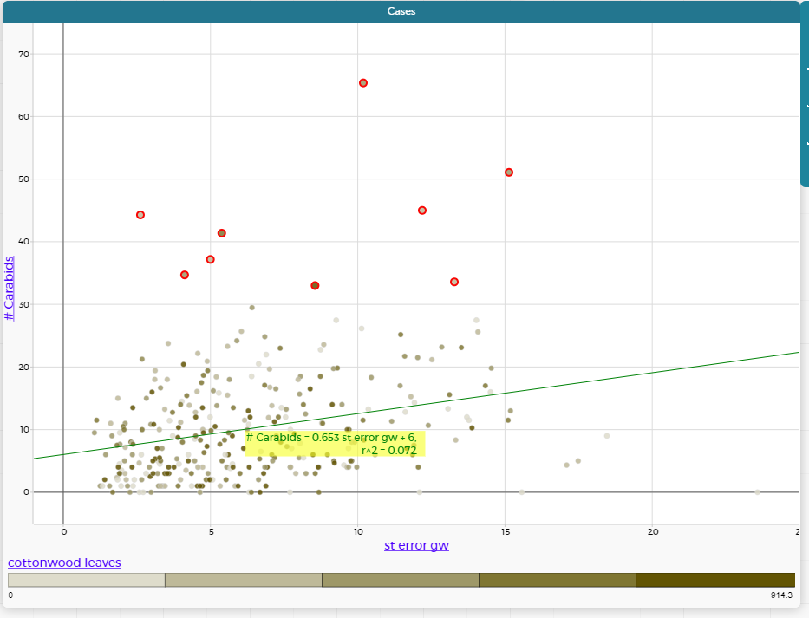

How does groundwater variation (st error gw) correlate with number of carabid beetles (# carabids)? How does the amount of cottonwood leaf fall (cottonwood leaves, in shades of greenish brown) contribute to this relationship? Where are the highest numbers of carabids found? (The highlighted data points, in red, show up in blue on the map below.)

